Non-random Loss Paper

Nutnet portions for Nathan Methods Additions

July 10 2020

*Nutrient Network: Non-random changes in biodiversity through time and in response to nutrient enrichment*

Next we use data from the Nutrient Network (Borer *et al.* 2014) to explore changes in rare, subordinate, and dominant species in response to nutrient addition through time (see Supplementary Information for full methodological details and classifications of species). This study includes **1715** species, across **43** grassland sites on **6** continents. The dataset followed standardized protocols for experimental design and sampling. At each site, a factorial combination of phosphorus (P), nitrogen (N) and potassium (K+µ; including a one-time addition of micronutrients) was applied for a total of eight nutrient treatment combinations.As a measure of ecosystem functioning, we consider productivity in terms of above-ground live biomass, which provides a good estimate of primary productivity in herbaceous vegetation (refs).

For biodiversity change of rare and dominant species, we consider two dimensions of change, estimating: (1) the average changes in abundance and richness of rare, dominant, and subordinate species based on each nutrient addition treatments compared to controls; and (2) changes over time, in terms of the probability of loss over time for rare, dominant, and subordinate species by treatment. For (1), we classify species in groups of rare, dominant, and subordinate based on their average relative cover per plot in the pre-treatment year ~~for each site~~ (see SI); we use cut-offs consistent with those for PREDICTS (lowest 20% rare and most abundant 20% as dominant), and demonstrate the robustness of results to this choice of cut-off in the SI (Figs. SX & SX). For (2), we consider the probability of loss in two ways: First, we model effects over the full length of the study by classifying a species as lost if it is present prior to treatment and is absent at the end of the experiment. Second, we quantify yearly effects by classifying a species as lost each treatment year if it is absent in the preceding year.

As for the BioTime dataset, we used a generalized linear mixed model with a binomial error and logit link to determine the relationship between initial relative abundance or biomass of a species at time 0 of a given time series and whether it was lost by the end (see SI). This model used both a random slope and intercept by study.

**Results**

**Nutrient Network Results [To write Up** Using Rel Abundance Group 1 – main results at the end of the duc]

**SI Methods**

**SI Dataset Descriptions**

*Nutrient Network*

Nutrient treatments were randomly assigned to 5 × 5 m plots and replicated in three blocks at most sites (range from x to x). Nutrients were applied annually, before the beginning of the growing season, using the following application rates and sources: 10 g N m-2 year-1 as time-release urea or ammonium nitrate (NH4NO3), 10 g P m-2 year-1 as triple-super phosphate (Ca(H2PO4)2) and 10 g K m-2 year-1 as potassium sulphate (K2SO4). In addition, 100 g m-2 of a micronutrient mix of Fe (15%), S (14%), Mg (1.5%), Mn (2.5%), Cu (1%), Zn (1%), B (0.2%) and Mo (0.05%) was applied once with K at the start of the experiment to avoid toxicity of more immobile micronutrients. We included all sites with at least 5 years of post-treatment data collection (range x to x). For each site and each year, plant species richness and aboveground live biomass were measured in standard and immediately adjacent 1 m2 plots. Aboveground live biomass was estimated by clipping at ground level all individual plants rooted within two 0.1 m2 (10 x 100 cm) strips, followed by drying to constant mass at 60⁰C and weighing to the nearest 0.01 g. Above-ground live biomass is a good estimator of primary productivity in herbaceous vegetation (Lauenroth et al 1986; Oesterheld M .& McNaughton, S. 2000). Note that to assemble a complete list of species, some sites with strong seasonal communities estimated biomass and richness twice during the growing season. For those sites, summed biomass of each species was used in the analyses.

**SI Methods**

*Classifying Species as Rare, Subordinate, or Dominant*

We assign the labels “rare,” “subordinate,” and “dominant” based on the average relative cover of a species, as a measure of relative abundance. We compute average relative cover for a species and site, based on *live* cover only in the pre-treatment year data, where relative abundance is the abundance of a species in a plot and year as a fraction of the total abundance of all species in the same plot and year. We then classify each species based on their relative abundance~~.~~

To group each species as rare, dominant, or subordinate at a given ~~site~~ plot, we use two sets of cut-offs, to assess the sensitivity of the results to this grouping decision. The first cut-off, presented in the main text, defines rare species as the 20% least abundant species in a given plot in the pre-treatment year. In contrast, dominant species were the top 20% of species, and subordinate species were the middle 60% (Fig. SX A). The second cut-off expanded the definition of rare species to include the 40% of species with the lowest relative abundance per site; whereas dominant were still classified as the top 20% most abundant species at a site (see Figure SXB). With these groups, we then assess changes in the number of species in each group per ~~plot~~ site through time and in response to each nutrient addition treatment, as well as changes in the cover of these groups of species per ~~plot~~ site through time and in response to each treatment. To capture the interaction between treatment effect and our species classifications, we average relative abundance and cover over all species within a site belonging to the same treatment group and pre-treatment abundance classification. Percentage differences between the treatment and control averages were then computed for each abundance group at every site. The distribution of these percent differences are displayed as boxplots (Boxplot Figures).

To capture temporal variation in treatment effect, we average relative abundance and cover over all species within a shared treatment and site at each treatment year. Comparisons with controls are made using yearly percentage differences, and these differences are then averaged over all sites at each treatment and treatment year. (Line graph figures at the very bottom of the page)

*Quantifying the probability of a species remaining through time*

We use two models to quantify the likelihood of species losses through time: one modeling the probability of loss at the end of the study using relative pre-treatment abundance, and one modeling the probability of loss at a given year using the species’ relative abundance in the preceding year.

We begin modeling the probability of a species persisting in a plot for the duration of the study by classifying a species as ‘lost’ if it is present in the pre-treatment year and absent at the end of the study. We then use the `lme4` package in `R` to fit a generalized linear effects model with a binomial link to express the probability of loss as a function of pre-treatment abundance and treatment (Bates *et al* 2015). In particular, we represent abundance using a rank of pre-treatment species abundance within a plot. We also include an interaction term between abundance rank and treatment, which allows the relationship between abundance and species loss to vary by treatment in our model. Additionally, we allow for varying intercepts within a site and plot, as well as a varying intercept by species. More formally, we fit the model:

where indexes over sites, indexes plots within sites, and indexes species within a plot.

For the second set of models, we model yearly effects by re-scaling loss to be annual; that is, we classify a species as lost in a given year if it is present the prior year and absent in the current year. Similarly, we replace pre-treatment abundance with abundance in the prior year. This leads to the modified model specification:

where is any treatment year, ranging from 1 to 10.

**SI Analyses and Results**

**Testing the robustness of the Nutrient Network results to the choice of cutoffs for rare, versus dominant.**

**Figure SX.** Results for the change in abundance by treatment for dominant, rare, and subordinate species, comparing results for two different cut-offs for defining how species are classified as rare versus dominant. The left panel shows the results presented in the main text (i.e., using cut-off 1: the least abundant 20% of species and dominant to be the top 20% of species (), whereas the right panel uses a cut-off that expands the definition of rare species to include the 40% of species with the lowest relative abundance (cover) per site.

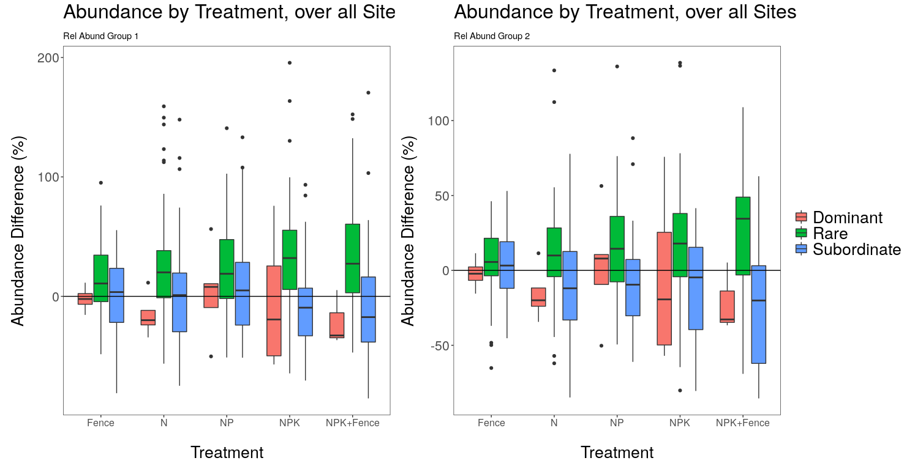

**Figure SX.** Results for the change in species richness by treatment for species characterized as: dominant, rare, and subordinate species, comparing results for two different cut-offs for defining how species are classified as rare versus dominant. The left panel shows the results presented in the main text (i.e., using cut-off 1: the least abundant 20% of species and dominant to be the top 20% of species (), whereas the right panel uses a cut-off that expands the definition of rare species to include the 40% of species with the lowest relative abundance (cover) per site.

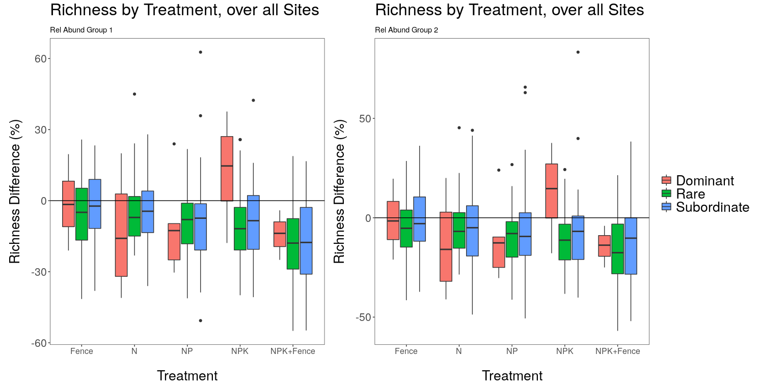

**Potential Figures below - Results Main Text.**

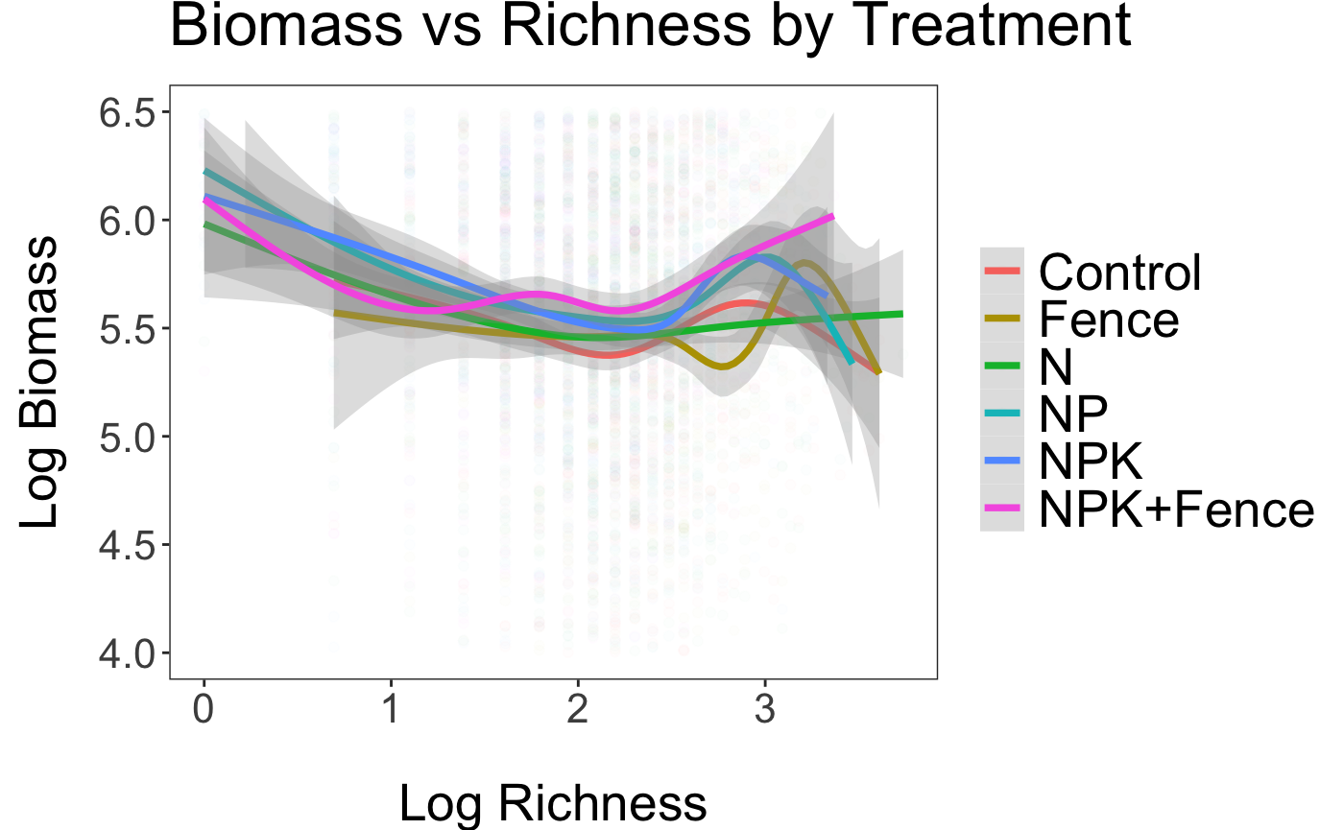





Figure 2:

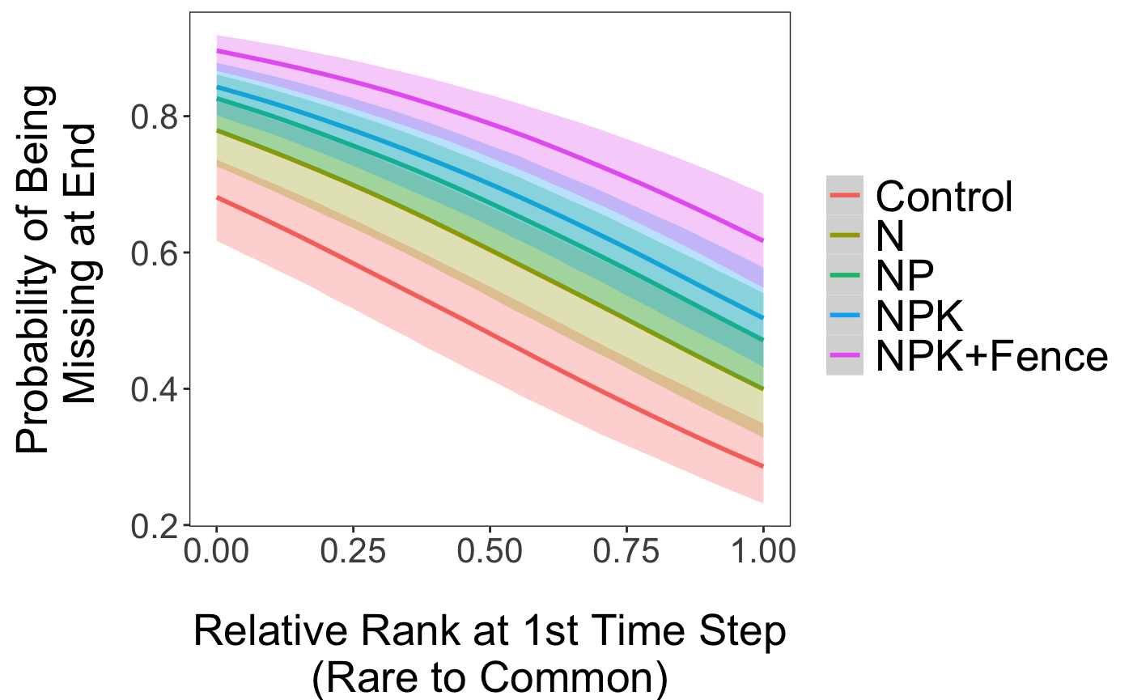

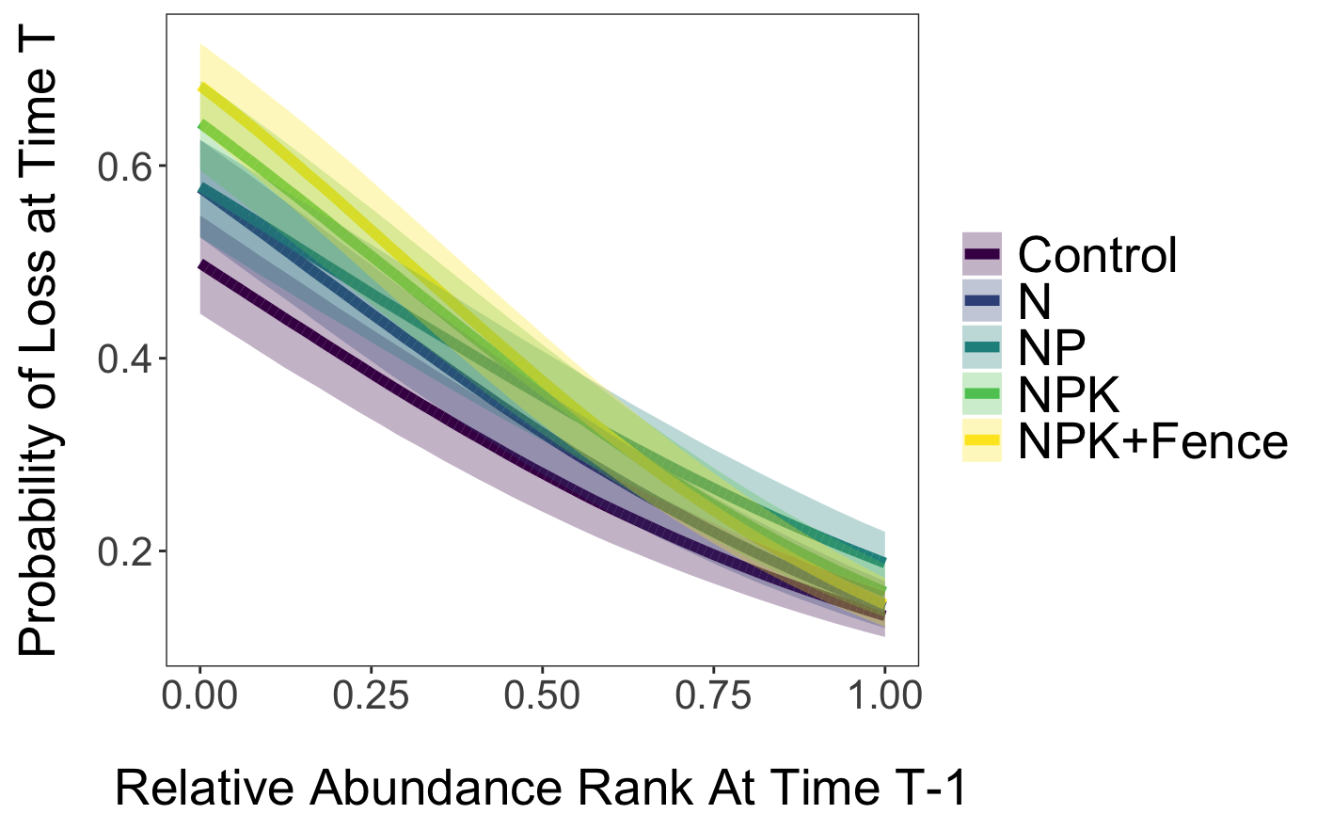

Biomass –

